Wondering Robot
Based off the PICAXE Buggy
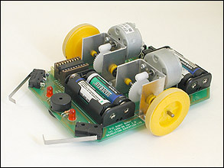

Supplies Needed:

2 Lever Switches - $2.99 each @ Radio Shack
8 NPN Transistors - Package of 15 for $2.99 @ Radio Shack
1 Photocell – Package of 5 for $2.99 @ Radio Shack
2 DC motors – Around $2.00 pending on type and where purchased, free is salvaged
1 Microcontroller – Suggest PICAX 18X1 for $8.65 @ http://www.robotshop.com/
Other Hardware and supplies ex: wood, metal, gears, batteries – Cost up to design specifications.

Total Cost: About $20.00 each

Cost of PICAXE Buggy Kit: $174.00 each

Step 1: Design the robot
First thing you would need to do is design the the robot itself. My design was based off the above picture of a PICAXE Buggy.

Step 2: Design the circuit
This step can be skipped pending if you brought a prebuilt board or not. I used a PICAXE 28 Pin Project Board hooked up to two H-Bridges to run the motors. An H-Bridge is four transistors hooked up to an electric motor. You can also use a CAD program to make your own PCB (printed circuit board) using the toner transfer method. A free CAD program for this is EAGLE from http://www.cadsoftusa.com/.
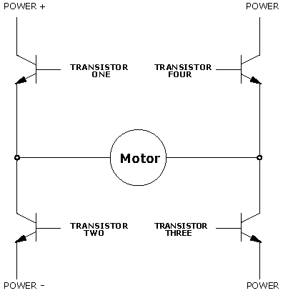
A simple H-Bridge Circuit

Step 3: Assembly
Assemble the robot.

Step 4: Programing the Microcontroller
PICAX microcontroller use a variation of the BASIC programing language and is very simple to understand and it's Development Environment, which can be downloaded from their website for free, comes with its own tutorial and all the resources you will need. When writing the program don't expect it to work the first time it will take some trial and error to get everything right.

Resources:
www.robotshop.com
www.rev-ed.co.uk
www.instructables.com
www.cadsoftusa.com
www.sparkfun.com
www.digikey.com
www.societyofrobots.com
For the code:
https://github.com/JoshLee0915/WonderingRobotProject

